WOMEN HEALING THE WOUNDS
THE NATIONAL COUNCIL OF CATHOLIC WOMEN
Cares About Your Safety

You are not alone, there is help for you
Nearly 75% of men who abuse their partners also abuse their children. Many times they are forced to witness the abuse. Children who grow up in abusive households are 42% more likely to perpetuate the cycle of violence.
LOCAL SHELTER
[Phone]
LOCAL SHELTER
[Phone]
LOCAL SHELTER
[Phone]
LOCAL SHELTER
[Phone]
LOCAL SHELTER
[Phone]
LOCAL SHELTER
[Phone]
LOCAL SHELTER
[Phone]
LOCAL SHELTER
[Phone]
LOCAL SHELTER
[Phone]
LOCAL SHELTER
[Phone]
LOCAL SHELTER
[Phone]
- Make a safety plan
- Contact a local shelter
- It is not Your Fault

1-800-799-SAFE (7233)

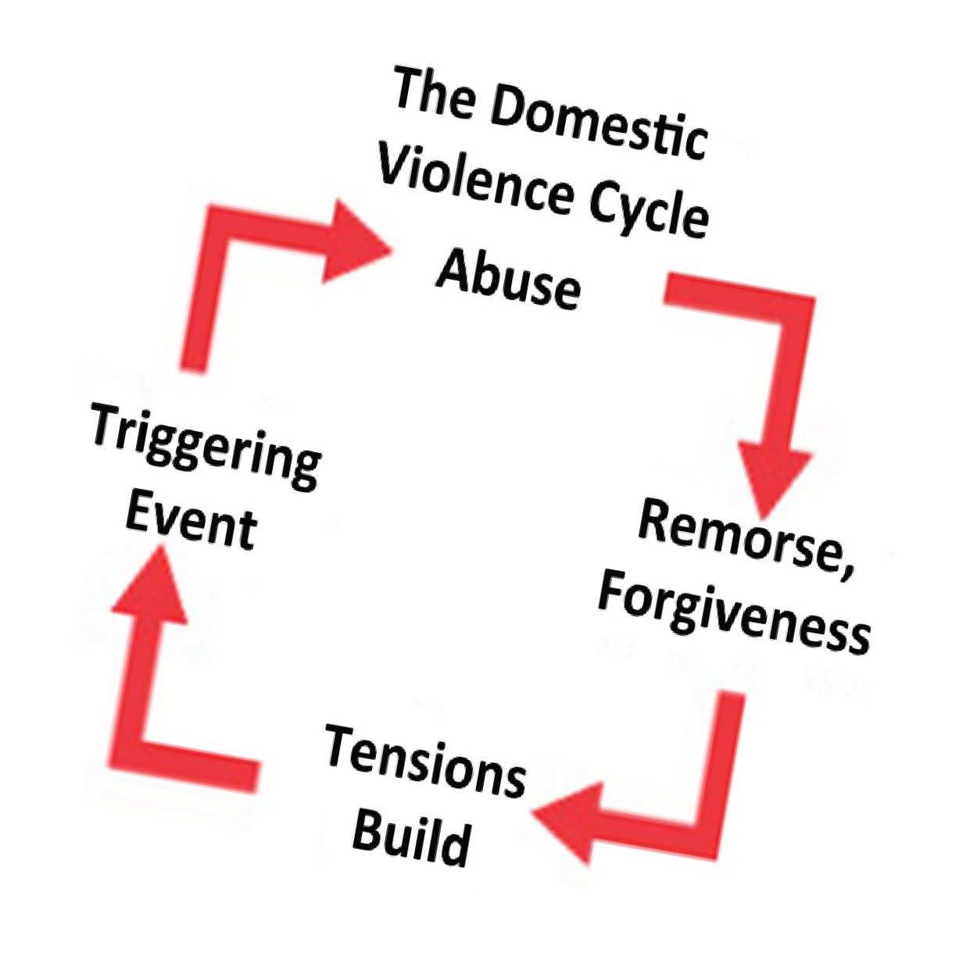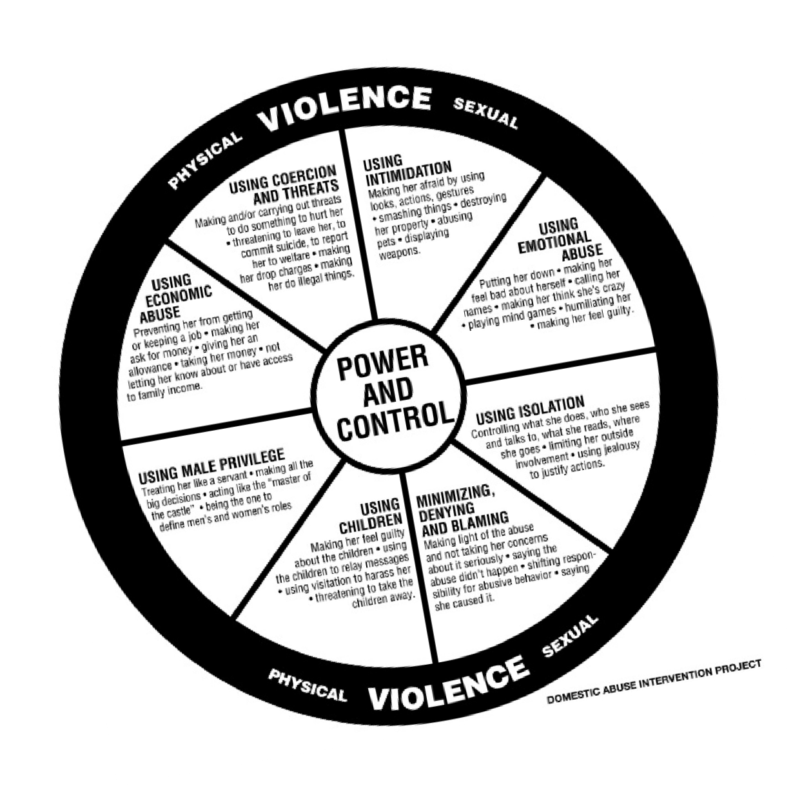
LOCAL SHELTER
[Phone]
LOCAL SHELTER
[Phone]

